The Chillicothe and Ross County Public Library
Board of Trustees
November 8, 2023

Present: Board Members Tamra Lowe, Lori Graves,
Retha Simmons-Jones and Rob Augg
Angela Hirsch, Susan Congrove
and Student Trustee Jackson Kohls

Absent: Cathy Adams

Others Present: James Hill, Executive Director
Cassie Stout, Chief Fiscal Officer
Wendy Payne, Deputy Fiscal Officer
Erin Lyons, Enrichment Director
Courtney Lewis, Comm. & Mrkt. Manager
Kelly Smith, HR Manager
Liz Gibbons-Camp, Enrichment Svcs Manager

The meeting was called to order at 4:30 p.m. by Tamra Lowe, President.
Jackson Kohls was welcomed as the new Student Trustee.

PUBLIC COMMENT

Pam McGinnis was in attendance and spoke on library landscape projects and library services.

Gen. Fin. “C”

Resolution 59-23

CONSENT AGENDA

A Hirsch moved and S. Congrove seconded the adoption of the following resolution.

That the minutes of the October 9, 2023 Regular meeting be approved as presented and,

That the following donations be accepted:
$20 anonymous donation to be used toward patron/program snacks
$5 unrestricted anonymous donation and,

That the financial reports as presented from Fiscal Officer’s records and the monthly financial statements of the Fiscal Officer for October be received and filed for audit and,

That the bills listed under date of November 8, 2023 be approved for payment.

The roll being called, the vote resulted as follows:
T. Lowe Y L. Graves Y A. Hirsch Y
R. Augg Y S. Congrove Y R. Simmons-Jones Y

October Financial Report

Clerk's Balance October 1, 2023 |  | $ 6,312,052.01
October Receipts | + | $ 324,594.46
Total |  | $ 6,636,646.47
October Expenditures | - | $ (541,029.57)
Ledger Balance October 31, 2023 |  | $ 6,095,616.90
Outstanding Checks | + | $ 8,260.05
Total |  | $ 6,103,876.95
Petty Cash | - | $ (475.00)
Doris T. Culp Fund - Stock | - | $ (10,500.00)
Anne R. Schlegel Fund - KNB CD | - | $ (10,000.00)
Kingston Money Market | - | $ (453,581.10)
Star Ohio | - | $ (5,348,574.47)
UBS/LPL Certificate of Deposit | - | $ (235,000.00)
Johnson-Laux Construction Retainage Sav. |  | $ (36,720.00)
Checking Balance |  | $ 9,026.38

Approval of Bills November 8, 2023

CRCPL | Gross Payroll 10/13 | $82,031.89
Internal Revenue Service | Library's Share of Medicare | $1,128.97
OPERS | Library's Share of OPERS | $23,829.67
Andrew Loewendick | Marketing Signage: "READ" letters | $300.00
Buckeye Propane | Frankfort Svc | $155.00
BP | Vehicle Fuel | $560.44
Captain Steamer | Main & N Side Carpet/Tile Cleaning | $988.50
Century Link/Lumen | S Salem Phone | $9.20
EasterSeals | Discovery Garden Annual Support | $5,000.00
Frontier | S Salem Phone | $123.18
Gordon Flesch | Copier Lease & Use | $633.76
Horizon | Telephone/Internet | $5,314.08
Jennifer Coffil | Mileage - OLC Convention | $146.21
Johnson-Laux | Annex Reno Pay App #3 | $181,332.00
Michael J Hart | Staff In Service Presentation | $500.00
Overdrive | ODL E Books | $3,343.96
Office City | Main Circ Chair | $611.93
Rumpke | Kingston, F Fort, R Dale, Main Svc | $529.42
Sherwin-Williams | Paint & Supplies | $67.94
T-Mobile | Cell Phone Svc | $131.53
First Data/Clover | Monthly Merchant Svc Device Fee | $8.53
Amazon | Program Supplies, Beyond Books | $980.20
Centerpoint | Large Print Books | $243.30
Communico | Scheduling Module Software | $2,978.41
Kendra Kempton | HRA Reimbursement | $323.41
Kelsey Holmes | Mileage 01/26 - 05/26 | $387.76
M & M Fabrication | September Mowing & Trimming | $2,425.00
NEO-RLS | M. Alexander Webinar | $40.00
Pike Natural Gas | R Dale Svc | $18.82
Ross Co Social Svc Council | Angency Membership | $25.00
State Industrial Products | Air Care | $183.39
Screenpoint | Pre Employment Background Chks | $35.00
Treasurer State of Ohio | SEO Consortium Fees | $14,595.51
The Water Express | S. Salem Water | $9.95
CRCPL | Gross Payroll 10/27 | $82,624.08
Internal Revenue Service | Library's Share of Medicare | $1,137.56
Anthem | Library's Share of Medical Premium | $31,893.17
AEP | Main, Annex, N Side | $3,545.32
Bainbridge Comm. Cntr | Rent & Electric | $1,365.44
Columbia Gas | Main, N Side, Kingston | $1,058.36
CDW | Computer Equipment | $2,675.39
Delta Dental | Library's Share of Dental Premium | $1,238.85
Gordon Flesch | Copier Use/Maint | $454.13
JLS | Frankfort HVAC Replacement | $8,300.00
OLC | Additional Expo Attendance | $210.00
Patron Point | Admin Software | $2,303.00
Rhoads | Front of Main Landscaping | $9,970.00
SEBO | Group Term Life Premium | $239.85
South Central Power | Kingston & Frankfort | $360.00
USPS | Refill Postage Meter | $1,000.00
VSP | Library's Share of Vision Premium | $626.21
All State Termite | Quarterly Pest Treatment 6 Buildings | $680.00
Baker & Taylor | Books | $16,499.47
Bayscan | TP Supplies | $169.00
BJs Electric | Massievile Book Hive Data Lines | $1,300.00
BP | Vehicle Fuel | $422.99
Central Center Hardware | Maintenance Supplies | $37.94
Cengage | Large Print Books | $2,003.29
Chillicothe Utilities | Water & Sewer | $743.04
Davis & Newcomer | Elevator Maintenance | $973.44
Dell | Computer Equipment | $46,469.09
DTB Distributors | Custodial Supplies | $1,602.72
Findaway/Playaway | A/V | $54.14
FlowMasters | Northside Water Heater | $1,404.31
Gordon Flesch | Copier Lease | $340.76
Kimberly Baker | HRA Reimbursement | $63.83
Landscape Mgmt Group | Annex Landscape Final Pay App #3 | $30,211.15
Lowes | Maintenance Supplies | $249.55
Library Ideas | Freegal | $6,500.00
Midwest Tape | A/V & Hoopla Flex | $5,969.95
Overdrive | ODL E Books | $3,440.03
OLC | IT Conference: 4 Registrants | $380.00
Quill | Office Supplies | $776.79
Ross Co Water | Richmond Dale Water | $26.87
Village of Frankfort | Water & Sewer | $30.00
Village of Kingston | Water & Sewer | $45.00
KNB Credit Card | Supplies & Annex Stools | $2,192.31
CRCPL | Gross Payroll 11/10/23 | $82,777.82
Internal Revenue Service | Library's Share of Medicare | $1,140.18
OPERS | Library's Share of OPERS | $23,041.53
 |  | $707,538.52

Director’s Report

Welcome to the holiday season! After a fast summer and early fall, it feels like we’re in the thick of shopping and decorating already.
Thank you to the board members who were able to attend the October In-Service Day. As always, it’s good to get everyone together in front of the staff. I had a lot of positive feedback about our morning speaker, Mickey Hart from United Campus Ministries in Athens. His presentation on unconscious bias opened our eyes about not just about daily interactions, but also things like how someone dresses, if they have tattoos, accents, family names, etc.
The strategic plan is getting closer to kicking off. We have a final survey that will be marketed to the community soon. If you’d like to look at it, you’ll find it here: https://www.surveymonkey.com/r/CRCPL2023. Your responses won’t be recorded yet if you answer the questions. We also need to schedule a board workshop with Erin Kelsey from the State Library to formally get your input.
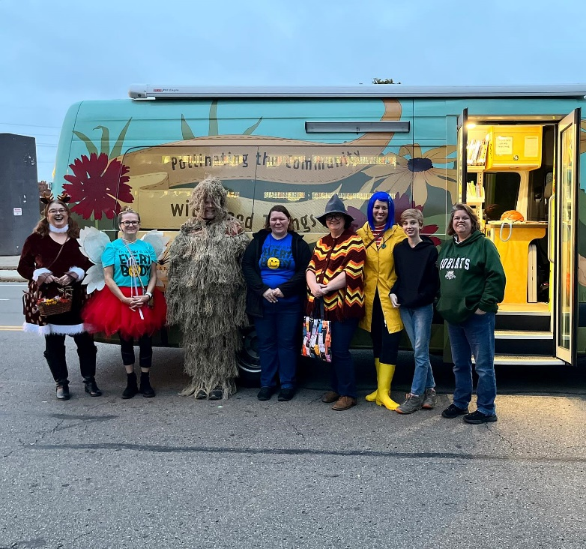
The library participated again in the downtown Halloween parade last weekend. We had folks handing out library-themed fortune cookies; Michelle Duncan drove the Bee and Wendy and I rode bicycles. It was great fun and fortunately the rain held off.
As happens every October, the staff appraisals have been completed. Everyone has a meeting with their manager or director to evaluate the last 12 months and, more importantly, to establish goals for the next year. Evaluation scores will be tallied and presented for merit increases as part of the 2024 budget proposal.
As previously reported, a couple of weekends ago we had a report of an assault in the main parking lot on a Saturday afternoon. After reviewing the video, we realized it was a false alarm. We did have a safety meeting with key staff that following Monday and reviewed the relevant policies and procedures. We will continue to train staff in how to handle these reports going forward and are seeking input from outside sources to review our policies and advise us on best practices. We will be updating the security cameras on a rotating basis starting next year. It was a stressful day that gave us an opportunity to evaluate our response. Chillicothe Police Chief Ron Meyers is presenting at the November All Staff meeting with tips and suggestions for handling these situations.
We recently received word from a handful of sources about an anonymous petition that’s being circulated in the county calling on the library to quell our collections and displays concerning LGQTB+ materials. Other than seeing a screenshot of the petition, there has not been a formal request made yet of me to address the issue. I did send an all-staff and board email about it just to keep everyone up-to-date in case you get questions. We are continuing to monitor the situation.
Finally, on Friday, November 3, I attended the virtual awards ceremony from North Carolina University’s inaugural “I Partner with My Library.” I nominated the city’s transit department for our work on the bus hub and shelter stop. The overall partnership program will
be featured in an upcoming issue of Public Libraries Magazine and I’ve been asked to submit comments for the article.

Annex Renovations Update & Ratify Annex Renovations Change Order #4
We’ve had a minor delay with state fire inspections, but we’re not too far off our original schedule. Phase 1 and 2 are nearly done. After we get a temporary occupancy permit for the 5th St. end of the Annex, we’ll be able to finish the remainder of the project. We’re still hoping to be finished in very early 2024. We did have a change order involving cement work for the Bee canopy outside of the new Outreach room in the amount of $12,720.00. We had enough in contingencies to cover the expense, so we were comfortable approving the change and asking for a ratification from the board.

Gen Fin. “A”
Resolution 60-23
Ratify Johnson-Laux Change Order #4
L. Graves moved and R. Augg seconded the adoption of the following resolution.
That the Executive Director be authorized to contract with Johnson-Laux Construction for additional Annex Renovations detailed as:
Change Order #4: $12,720 – Concrete and Sidewalk for Bookmobile Canopy Area

The roll being called, the vote resulted as follows:
T. Lowe Y L. Graves Y A. Hirsch Y
R. Augg Y S. Congrove Y R. Simmons-Jones Y

Personnel Committee Update
The Personnel Committee met on October 17 in the Annex to discuss a handful of issues. In attendance were Tamra, Lori, Kelly Smith, Wes Campbell from Structured Employee Benefits of Ohio (SEBO), and James.
  - HR policy updates—as part of our on-going review, Kelly and I have revised a handful of HR policies (see separate handout). The changes are tracked in the Word document for easier reference. The two policies that are redundant are included in Administrative Policy.
  - Volunteer policy updates—since the pandemic, our volunteer program has been on hold. We would like to ramp up the program again, but wanted to take the opportunity to fine tune the details, starting with revising the existing policy (see separate handout).
  - Custodial staffing—as we’ve increased our public spaces outside and added vehicles and new space at the Annex, we took a look at our custodial services (see separate handout) and would like to increase our staffing to adequately cover all of the needs.
  - Vision, dental, life, short term disability proposal—the library hasn’t changed vision, dental or life insurance providers in many years (if ever in some cases). Kelly worked with Wes to evaluate our offerings and come up with some alternatives, primarily a bundled package from Guardian (see handout).
Pols. “A”
Resolution 61-23
Approve Policy Updates: HR 3.1, HR 3.4.1, HR 5.5, HR 5.11 and delete duplicates HR 4.16 & HR 5.12. Approve Policy Updates to Volunteer Policy 1.10
A Hirsch moved and R. Augg seconded the adoption of the following resolution.
That the HR and Volunteer Policies identified above be updated as presented.

The roll being called, the vote resulted as follows:
T. Lowe Y L. Graves Y A. Hirsch Y
R. Augg Y S. Congrove Y R. Simmons-Jones Y

Pers. “A”
Resolution 62-23
Approve Adding Additional Custodian Position
L. Graves moved and S. Congrove seconded the adoption of the following resolution.
That an additional Building Custodian position be added in the Facilities Department using the current job description.

The roll being called, the vote resulted as follows:
T. Lowe Y L. Graves Y A. Hirsch Y
R. Augg Y S. Congrove Y R. Simmons-Jones Y

Discussion of Insurance Bundle Proposal

2024 Budget Discussion & Schedule Budget Committee Meeting
Cassie has been diligently working through the new budget codes to bring us into compliance with the 2024 changes required by the state. We need to schedule a Budget Committee meeting to go over the changes and to look at next year’s projected revenue and expenses for full consideration at the December board meeting. Retha (Chair), Angela, and Rob comprise the Budget Committee. Meeting scheduled for November 30th at 5:00 PM.

Upcoming Board Vacancy Discussion
January 2024-2031 board opening—Commissioners’ appointment: I have two names for consideration to replace Susan who is terming out at the end of this year. This is a county commissioner’s appointment, so whoever we invite will need to fill out their application and get approved by them.

2024 Officers Nominations Committee
Nominations Committee—The January Organizational meeting will be here soon. That’s when new officers, per the Ohio Revised Code, must be elected.

Adjourn at 6:04p.m.

______________________________ _____________________
Retha Simmons-Jones, Secretary Tamra Lowe, President

