Director’s Report
November, 2023

Welcome to the holiday season! After a fast summer and early fall, it feels like we’re in the thick of shopping and decorating already.
Thank you to the board members who were able to attend the October In-Service Day. As always, it’s good to get everyone together in front of the staff. I had a lot of positive feedback about our morning speaker, Mickey Hart from United Campus Ministries in Athens. His presentation on unconscious bias opened our eyes about not just about daily interactions, but also things like how someone dresses, if they have tattoos, accents, family names, etc.
The strategic plan is getting closer to kicking off. We have a final survey that will be marketed to the community soon. If you’d like to look at it, you’ll find it here: https://www.surveymonkey.com/r/CRCPL2023. Your responses won’t be recorded yet if you answer the questions. We also need to schedule a board workshop with Erin Kelsey from the State Library to formally get your input.
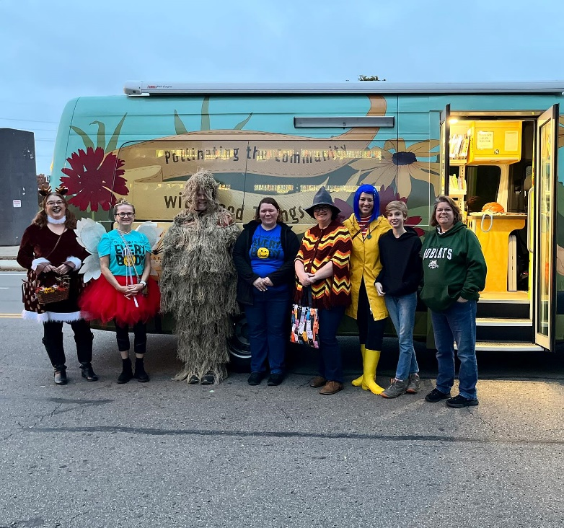
The library participated again in the downtown Halloween parade last weekend. We had folks handing out library-themed fortune cookies; Michelle Duncan drove the Bee and Wendy and I rode bicycles. It was great fun and fortunately the rain held off.
As happens every October, the staff appraisals have been completed. Everyone has a meeting with their manager or director to evaluate the last 12 months and, more importantly, to establish goals for the next year. Evaluation scores will be tallied and presented for merit increases as part of the 2024 budget proposal.
As previously reported, a couple of weekends ago we had a report of an assault in the main parking lot on a Saturday afternoon. After reviewing the video, we realized it was a false alarm. We did have a safety meeting with key staff that following Monday and reviewed the relevant policies and procedures. We will continue to train staff in how to handle these reports going forward and are seeking input from outside sources to review our policies and advise us on best practices. We will be updating the security cameras on a rotating basis starting next year. It was a stressful day that gave us an opportunity to evaluate our response. Chillicothe Police Chief Ron Meyers is presenting at the November All Staff meeting with tips and suggestions for handling these situations.
We recently received word from a handful of sources about an anonymous petition that’s being circulated in the county calling on the library quell our collections and displays concerning LGQTB+ materials. Other than seeing a screenshot of the petition, there has not be a formal request made yet of me to address the issue. I did send an all-staff and board email about it just to keep everyone up-to-date in case you get questions. We are continuing to monitor the situation.
Finally, on Friday, November 3, I attended the virtual awards ceremony from North Carolina University’s inaugural “I Partner with My Library.” I nominated the city’s transit department for our work on the bus hub and shelter stop. The overall partnership program will be featured in an upcoming issue of Public Libraries Magazine and I’ve been asked to submit comments for the article.

OLD BUSINESS:

Annex renovation update/ratify change order: We’ve had a minor delay with state fire inspections, but we’re not too far off our original schedule. Phase 1 and 2 are nearly done. After we get a temporary occupancy permit for the 5th St. end of the Annex, we’ll be able to finish the remainder of the project. We’re still hoping to be finished in very early 2024. We did have a change order involving cement work for the Bee canopy outside of the new Outreach room. We had enough in contingencies to cover the expense, so we were comfortable approving the change and asking for a ratification from the board.

NEW BUSINESS:

Personnel Committee: The Personnel Committee met on October 17 in the Annex to discuss a handful of issues. In attendance were Tamra, Lori, Kelly Smith, Wes Campbell from Structure Employee Benefits of Ohio (SEBO), and me.
  - HR policy updates—as part of our on-going review, Kelly and I have revised a handful of HR policies (see separate handout). The changes are tracked in the Word document for easier reference.
  - Volunteer policy updates—since the pandemic, our volunteer program has been on hold. We would like to ramp up the program again, but wanted to take the opportunity to fine tune the details, starting with revising the existing policy (see separate handout).
  - Custodial staffing—as we’ve increased our public spaces outside and added vehicles and new space at the annex, we took a look at our custodial services (see separate handout) and would like to increase our staffing to adequately cover all of the needs.
  - Vision, dental, life, short term disability proposal—the library hasn’t changed vision, dental or life insurance providers in many years (if ever in some cases). Kelly worked with Wes to evaluate our offerings and come up with some alternatives, primarily a bundled package from Guardian (see handout).

2024 Budget—set Budget Committee meeting: Cassie has been diligently working through the new budget codes to bring us into compliance with the 2024 changes required by the state. We need to schedule a Budget Committee meeting to go over the changes and to look at next year’s projected revenue and expenses for full consideration at the December board meeting.

January 2024-2031 board opening—Commissioners’ appointment: I have two names for consideration to replace Susan who is terming out at the end of this year. This is a county commissioner’s appointment, so whoever we invite will need to fill out their application and get approved by them.

Nominations Committee—The January Organizational meeting will be here soon. That’s when new officers, per the Ohio Revised Code, must be elected.

Adjourn [ACTION]

